Rough draft: Justification & Computation
1. Off-the-Shelf Wheel Selection & Justification
1.1. Engineering Computations
- Dimensional Constraints: To maintain canopy clearance for 'Red Robin' tomatoes (approximately 30 cm height) and adhere to the physical constraints of a 30-inch doorway and a footprint of less than 1.5 square meters, the selected wheel diameter must be between 700 mm and 800 mm.
- Radial Load: The structure must support a maximum biomass load of 40 kg. Adding the estimated mass of three ultrasonic water baths (approximately 15 kg for fluid and housing), the total rotating mass is roughly 55 kg. The static radial load per wheel is calculated as (Total Mass * Gravity) / 2. Therefore, each wheel must support approximately 270 Newtons.
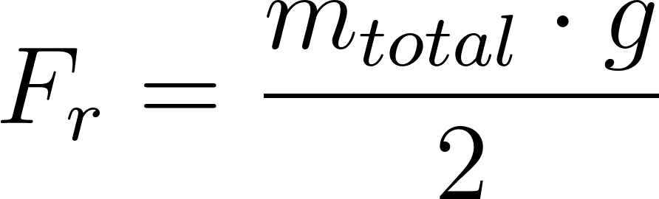
- Rotational Inertia: The wheel rim mass must be minimized so the 50 kg.cm planetary gear motor can execute the 5-second soft-start ramp without exceeding the stall current. Inertia is roughly the sum of mass times the square of the radius
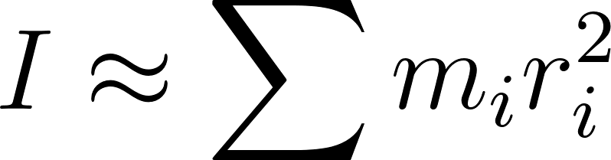
1.2. Component Selection
- Selected Component: 29-inch (700c) Aluminum Bicycle Front Wheel.
- Specifications: Outer diameter is approximately 736 mm; aluminum alloy rim; stainless steel tension spokes; integrated sealed hub bearings.
1.3. Engineering Justification
- Biological Clearance: The 736 mm diameter closely approximates the original 800 mm CAD specification , providing sufficient radial clearance for the gravity-leveled crop rows to pivot freely.
- Load Capacity & Safety Factor: Standard 29-inch bicycle wheels are engineered for dynamic impact loads exceeding 100 kg. This provides a Safety Factor (SF > 3.5) well above the 270 N static requirement.
- Environmental Reliability: The integrated sealed hub bearings naturally replace the planned ISO 608ZZ bearings and satisfy the corrosion resistance requirements for the high-humidity (>90%) aeroponic environment.
- Fabrication Efficiency: Utilizing a pre-trued, mass-produced wheel eliminates fabrication time and tolerance stack-up risks associated with assembling custom spoked wheels.
https://www.amazon.ca/Wheel-Shop-Stainless-spokes-FM21-FQR/dp/B01LX735CC/ref=sr_1_13?crid=3GCFSLFG7T4JP&dib=eyJ2IjoiMSJ9.ieF82O9B4cgEV8ZIBxc-VSAEzoCdQSsVscr83pPqH3-iVrS2FK_oM8D0nhwcmA7wZxf19BHCw5KEFuh9LUKd-wtH8HFe6iiBfHp9HQkf3ptIoCfTUuZIHMtwkT_A3j_xeeyQYSRRKWompqtj_zhPHZwMat5P2OZbt8HgHp3djbWpWwxtNJ4fVvpfEG-gPY5xWiA4a1d_BHtp1noEcgha3ShbVYQoyCVj7DarTFRoDjOr_RybV-PjYXvtU0xNkhzl9zhGp-qFpP_ZRdGBxnpxwKCCPjFeM930YJJXevcnxZY.IDekT_FQ5_jgvXV5VLl2dtUTZmlQECTr2rNosnZTn7g&dib_tag=se&keywords=700c+front+wheel&qid=1771980588&sprefix=700c+Front+Whee%2Caps%2C160&sr=8-13
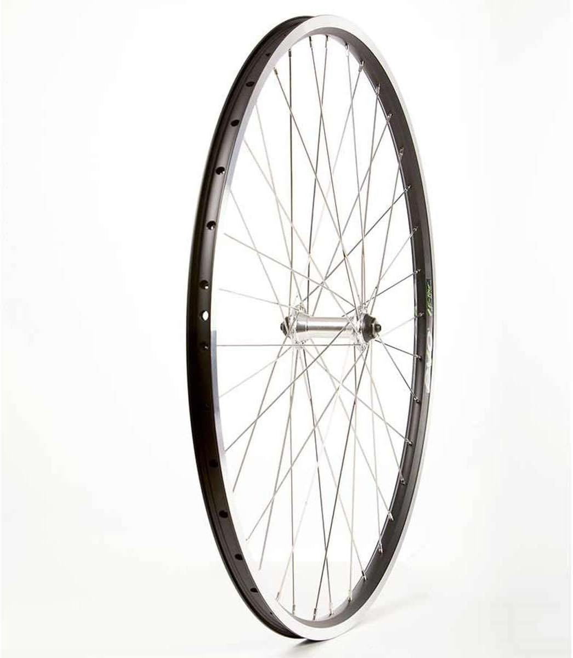
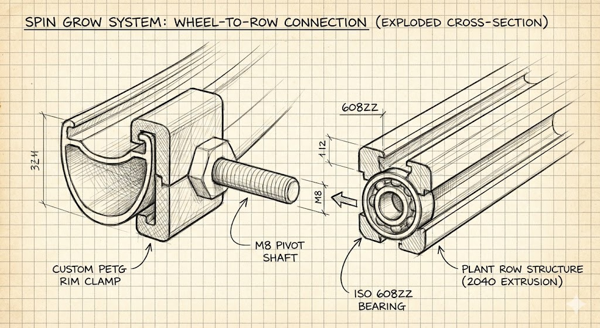

2. Ultrasonic Mist Generators (Foggers) & Water Bath
2.1. Engineering Computations
- Plant Load & Water Demand: 12 Red Robin tomato plants (4 plants x 3 rows). Estimated mature consumption is 200 mL/day per plant.
  - Total daily consumption = 12 x 200 mL = 2400 mL/day.
- Duty Cycle: 13.3% (4 min ON, 26 min OFF).
  - Active misting time = 24 hours x 0.1333 = 3.2 hours/day.
- Required Output Rate:
  - Total System Minimum = 2400 mL / 3.2 hours = 750 mL/hr.
  - Per-Row Minimum (3 rows) = 750 mL/hr / 3 = 250 mL/hr.
- Enclosure & Sealing: Each row functions as an enclosed root bath. Requires PETG enclosures for chemical resistance to nutrient salts (pH 5.5–6.5). Pivot joints require custom 3D-printed TPU gaskets (Shore 95A) or dual silicone O-rings for dynamic sealing during gravity-leveling rotation.
2.2. Component Selection
- Selected Components (3 units required of either option):
  - Ultrasonic Mist Maker, Single Head DC24V 650mA Ultrasonic Fogger
  - ciyeu Ultrasonic Mist Maker Fogger Atomizer
2.3. Engineering Justification
- Output Capacity: Both options are standard single-head units capable of producing mist volumes that comfortably exceed the 250 mL/hr minimum requirement for each row.
- Architecture Fit: The compact form factor of a single-head unit easily integrates into the enclosed, pivoting "common bath" of each of the 3 rows in the Spin Grow System.
- Durability: Both models feature metal construction, ensuring longevity and crucial corrosion resistance against continuous exposure to EC 1.5–2.5 mS/cm nutrient solutions.
- Algae Prevention: The strict exclusion of LEDs on both models ensures the root zone remains pitch dark, preventing harmful algae blooms inside the individual reservoirs.
Amazon Links: https://www.amazon.ca/Ultrasonic-Maker-Single-Fogger-Lasting/dp/B0D5GX4D9S
https://www.amazon.ca/ciyeu-Ultrasonic-Fountain-Atomizer-Humidifier/dp/B0CY4HRY66?source=ps-sl-shoppingads-lpcontext&psc=1&smid=A3BA0W7EEBSLCP
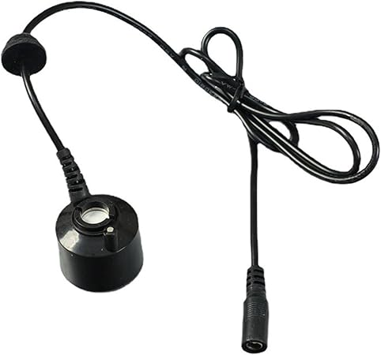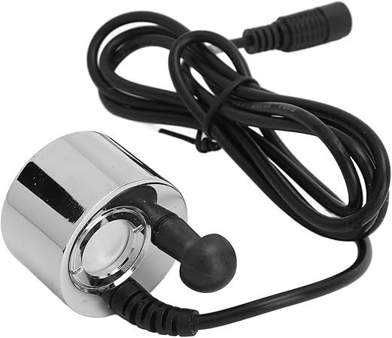

3. Power Transmission / Slip Ring
3.1. Engineering Computations
- Electrical Load: The system utilizes three 24V DC foggers. Each draws 650mA. Total system current = 3 x 650mA = 1.95A. The slip ring requires a minimum rating of 3A to safely handle continuous operation and potential inrush current from the foggers turning on simultaneously.
- Rotational Wear: The main horizontal cylinder rotates at a highly reduced speed (under 2 RPM). Friction and heat generation on the contacts will be completely negligible.
- Environmental Sealing: The component must be mounted externally on the main rotating shaft, completely outside the high-humidity growth chamber, to prevent electrical shorts.
3.2. Component Selection
- Selected Component: High Current Wind Power Capsule Slip Ring (22mm Diameter, 2 Channel, 10A).
3.3. Engineering Justification
- Current Capacity & Safety Margin: The 10A rating per channel provides an extensive safety margin (over 500%) for the 1.95A continuous draw. This completely mitigates the risk of contact overheating from inrush currents when the 13.3% duty cycle triggers the three foggers.
- Mechanical Integration: The standard capsule design with an integrated flange allows for direct and secure bolting to the external frame structure. The 2-channel configuration perfectly matches the 24V DC power delivery requirement (positive and negative) with no redundant wires.
- Longevity: Standard precious metal slip rings of this type are rated for continuous speeds of 250 to 300 RPM. Operating this component at 1-2 RPM ensures an essentially infinite mechanical lifespan for this specific application.
Amazon Link:
https://www.amazon.ca/Current-30ACurrent-Capsule-Sliprings-Rotary/dp/B0GLFVCGY8/ref=sr_1_12?crid=362UM3DGTLOGI&dib=eyJ2IjoiMSJ9.E188T7tSsNX_aliOVRd8DPEMJFi05J0uwjLSp3zlvsMo5ULrcfDJqG5pZjDfIg2ha-OMvnRYl_calwqii5Az8QRi8Ywfj6EnsyqWVXg-7J-2iLykiyqUbZKbsj1xXn69wC8w2Et2nFUD0QvjMoJXW0vzVhp6LXscPsgHxPi6kA2NbfGBKWhjOOVo_ClMKW7g463XyNMFvWw4zQptBuOt4OrCLeEuVHviq8x1FWGLhF8Hn745rb7GpOmi_iZ0PdcA1-tQnIFiSO4Ec1oWklk17ob4ATsKtKIcP2HnUNFG_Ls.LR3CP6CbRQRuwXN19nkFAVm1XhOfB9_86bxYmVT_iEg&dib_tag=se&keywords=slip%2Bcapsule%2Bslip%2Bring%2B10A&qid=1772584375&sprefix=slip%2Bcapsule%2Bslip%2Bring%2B10a%2Caps%2C137&sr=8-12&th=1
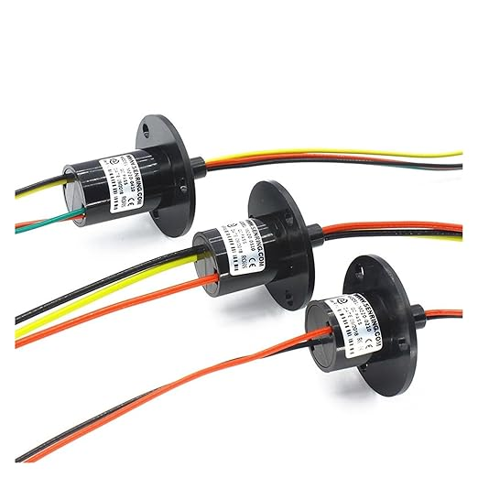

4. Electromechanical Drive System
- Engineering Computations:
  - Maximum unbalance torque (worst-case scenario: one row's bath is full, others are empty).
  - Required motor holding torque to prevent back-driving.
  - Required operational torque to maintain 0.5–1 RPM.
- Component Selection & Justification: * Re-evaluate the 50kg.cm planetary gear motor.
  - Justify whether a higher-torque stepper motor or a revised GT2 timing belt gear ratio is required for the added water mass.
5. Structural Frame
- Engineering Computations:
  - Static load bearing and beam deflection for the central axle and the base frame.
- Component Selection & Justification: * Justify retaining or upgrading the 2040 V-slot aluminum extrusion against the new payload parameters and the $750 CAD budget cap.
6. Control Electronics
- Engineering Computations:
  - Total system power budget (Motor + ESP32 + Ultrasonic units + 100W LED bar ).
- Component Selection & Justification: * Select AC/DC power supply sizing.
  - Justify solid-state relays for switching the ultrasonic units inside the IP65 dry box.

- Motor + Gearbox
STEPPERONLINE NEMA23 Planetary Gearbox 20:1
Roughly $80-$100 (Amazon)

Justification:

The NEMA23 stepper motor was chosen because it produces enough torque to reliably drive the 50kg rotating structure with room to spare. Paired with the 20:1 planetary gearbox, the motor's 2.8 N·m output is multiplied to approximately 50.4 N·m at the wheel shaft, well above the 20–30 N·m the structure actually needs. The 20:1 ratio also perfectly matches the speed reduction required to hit the 1 RPM target without needing any additional chain or belt drive. Stepper motors were preferred over regular DC motors because speed is controlled simply by adjusting pulse signals from the ESP32, with no encoders or sensors needed. The STEPPERONLINE MGL gearbox was specifically chosen for its all-metal construction and ground gear teeth, making it durable enough for continuous long-term use.

Probably can get at Aliexpress for cheaper ones.

https://www.amazon.ca/STEPPERONLINE-MGL-Gear-Ratio-Planetary/dp/B0DXZS8GHN/ref=asc_df_B0DXZS8GHN?mcid=8a55e72312cc3e699fa9631c34c3e3c4&tag=googleshopc0c-20&linkCode=df0&hvadid=706747361182&hvpos=&hvnetw=g&hvrand=5057109593281102390&hvpone=&hvptwo=&hvqmt=&hvdev=c&hvdvcmdl=&hvlocint=&hvlocphy=9001532&hvtargid=pla-2432735264118&psc=1&hvocijid=5057109593281102390-B0DXZS8GHN-&hvexpln=0&gad_source=1

- Stepper Driver

Justification:
The DM542T was chosen over the TB6600 because, at 1 RPM, smooth rotation matters a lot, and the TB6600 simply does not deliver that. The DM542 supports 1/128 microstepping, giving 25,600 steps per revolution compared to the TB6600's 6,400, which translates directly to much smoother and quieter motion. It also has a built-in processor that actively reduces motor vibration at low speeds, something the TB6600 completely lacks. Optical isolation on the signal inputs keeps the ESP32 protected from any electrical noise coming from the motor side. For a display that runs continuously, the DM542 is simply the more reliable and better-performing choice. However, if cost comes in play, the TB6600 can also be used, although not recommended

Option 1: DM542T (Best Option)
Roughly: $35 - $50 (Amazon)
https://www.amazon.ca/Digital-Microstep-Stepper-Controller-2-Phase/dp/B0BYVH3X1B/ref=sr_1_5?crid=1IZ91KW096HC3&dib=eyJ2IjoiMSJ9.Fup2fgFSLHGpzbhIr_9-9ojb6cMKRrLPazLMvUSm_othcFQfH1Qx76w87j-1BqdqKi0xHQxz0pvPFp8BqudmyxA2-JkOMCdgk3R414LR5CXCmJXwOn1WIrcIS_RXlKvZRcUhcedzZkzjIdPzf7AsyHnQvrPz18wsH4PHPv-iVFyjINaBGcYo-qSr8_LPuxcpcB5Uy8caPkWSTTrFHTcKUOzjIBPqTnR8Fp-b06a8sRTYxNSDHpiMS6j6zdnS3w7mpNUehAEaXjsL8T66-UU62w9F1M3Ussta3v-kwkcIws8.__nbu4JJkqefBXd_XOw5yR9EqlTOKHJS2SUbxl3yX2s&dib_tag=se&keywords=DM542t&qid=1772782824&sprefix=dm542t%2Caps%2C179&sr=8-5

Option 2: TB6600 (Budget Friendly)
Roughly: $15-$30 (Amazon)
https://www.amazon.ca/Yechiry-Isolation-Efficient-Industrial-Automation/dp/B0GCD8XCB3/ref=sr_1_2_sspa?dib=eyJ2IjoiMSJ9.FnVtfeZDaB62sfX5am_1OmOWLoW3OOPze6rWap_N0BHgotp1KSNpGMKMTg9XaxXp8pE_f7SfVjReTHM99fjZHwXassQgDxfN8mj9q7I9dIeQNklexjxzbZ7WaZoK9OWBVN5689gBx6FPddVnLWK9Ej2vE7UF3YsDwVdNItJsWAAIaCmkBQN4dlY_ariIj2NLuufx9kRvOK75nNHBqefTa_imZmQ_cBtXRsEZ9BPnfXHiNWLX3RNsJHuzXzL4qZgJo9g8BY3epRnpjXHjqWcebtiy-FGYZLiOhGa0ehz64qQ.xZ7f06HsclN0fhXauVMaNkbzBHr2i_RqwWM7EdfTXf0&dib_tag=se&keywords=TB6600&qid=1772781795&sr=8-2-spons&sp_csd=d2lkZ2V0TmFtZT1zcF9hdGY&psc=1

- Controller
ESP32 Dev Board
$26.95 (Amazon)
https://www.amazon.ca/dp/B0C9THDPXP?ref=cm_sw_r_cso_wa_apan_dp_ACXBJ3QCTNSX7PZDYXVM&ref_=cm_sw_r_cso_wa_apan_dp_ACXBJ3QCTNSX7PZDYXVM&social_share=cm_sw_r_cso_wa_apan_dp_ACXBJ3QCTNSX7PZDYXVM&th=1

- Power Supply
24V 10A DC Power Supply
Justification:

The Meanwell LRS-350-24 was chosen because it is one of the most trusted power supply brands used in industrial and professional equipment worldwide. The system only consumes around 80W in actual operation, meaning this 350W unit runs at just 23% of its capacity, keeping it cool and reducing long-term wear significantly. It also handles the large startup current spikes from the stepper motor without any issues, which cheaper supplies often struggle with. It carries UL, CE, and TUV safety certifications, which matter for any installation that runs unattended for long periods. Compared to generic alternatives, the Meanwell is simply a more dependable unit that is built to last.

Option 1: Mean Well (Industrial Grade)
Roughly: $45 -$55 (Amazon)
https://www.amazon.ca/LRS-350-24-Supply-Printer-Industrial-Control/dp/B07VRK86SP/ref=sr_1_8?crid=3NJ91O3UAXW6K&dib=eyJ2IjoiMSJ9.VgUtQcoX-HIB_BSh8985XdPOQuzwuY4hE-MSrNuEpPh_FnPGA9m8Y-TMi6dNnpspp5bWOfDBlgPEbaxApiFHjRC7ANvjnpbu8at0fFUDjVCwpYyWNxiWNFAPigNPW3XzK9TLGg4p_32cEzhn54wTM_a-SNoimZGqxmh-pX0JYsJosQ7Tx7sLP2_24AKhFlRcrOMnKFgrgEOBNZzP2HQelpj7fP3AWEu_KZBeqWNono_ZU5_eCiRuWI1CmU4l5box6pnJjIMfqdQ6RbyBdodIGNLjJWP5R4YrJla3M0OGpcI.eyP2VX-yBFjxbSv8VTrrTGx4_KdRn0s3wrppEdzmtjo&dib_tag=se&keywords=meanwell%2B24v%2B10A%2BDCpower%2Bsupply&qid=1772782502&s=industrial&sprefix=meanwell%2B24v%2B10a%2Bdcpower%2Bsupply%2Cindustrial%2C124&sr=1-8&th=1

Option 2: Padarsey (budget Friendly)
Roughly: $30 -$40 (Amazon)
https://www.amazon.ca/Padarsey-Transformer-Universal-Regulated-Switching/dp/B07CPXD8P3/ref=asc_df_B07CPXD8P3?mcid=c774792d63813872b8d6cffbd7ebc05a&tag=googleshopc0c-20&linkCode=df0&hvadid=706724917107&hvpos=&hvnetw=g&hvrand=13555299519969082569&hvpone=&hvptwo=&hvqmt=&hvdev=c&hvdvcmdl=&hvlocint=&hvlocphy=9001532&hvtargid=pla-1664031270388&psc=1&hvocijid=13555299519969082569-B07CPXD8P3-&hvexpln=0&gad_source=1

Some other parts:
-Bearing connecting the gutter to the wheel.
- Pillow Block Bearing
-Shaft coupler
- Connect Motor to Wheel
-Tray
-

purchase list: on going update

Component Purchase List

Category | Component | Est. Cost (CAD) | Quantity | Purchase Links
Structure | CDHPOWER 29"/700C Mag Wheelset | $111 | 2 | Amazon Link
 | PETG Filament (3kg) | $20.00 | 3 kg | Amazon Link
Rotation | STEPPERONLINE NEMA23 Planetary Gearbox 20:1 | $80.00 - $100.00 | 1 | Amazon Link
 | Stepper Driver: DM542T | $35.00 - $50.00 | 1 | Amazon Link
 | Stepper Driver: TB6600 (Budget Alternative) | $15.00 - $30.00 | 1 | Amazon Link
 | Pillow Block Bearing | $65.00 | 10 | Amazon Link
 | 25 mm Shaft Coupler | $9.69 | 2 | Amazon Link
 | Rotary Shaft 1566 Carbon Steel, 25 mm Diameter, 1200 mm Long | $70.93 | 1 | Mc Master link
Fluid System | Ultrasonic Mist Maker Transducer Humidifier Parts Head | $9.00 | 5 | Amazon Link
Electronics | ESP32 Dev Board | $26.95 | 1 | Amazon Link
 | breadboard kit, temperature probe, humidity sensor, reservoir, |  |  | In the lab
 | IP65 Waterproof Project Box for ESP32 Board 7.8" | $19 | 1 | Amazon Link
 | Relay modules |  |  | Link  link
 | Jumper wires
 | pH sensor
 | Waterproof coating for electronics | $17 | 1 | Amazon Link
 | Meanwell LRS-350-24 24V 10A DC Power Supply | $45.00 - $55.00 | 1 | Amazon Link
 | Padarsey 24V Power Supply (Budget Alternative) | $30.00 - $40.00 | 1 | Amazon Link
 | High Current Capsule Slip Ring (2 Channel, 10A) | $38 | 2 | Amazon Link
Others | 4-inch Mesh Pot | $20.00 | 20 | Amazon Link
 | Rockwool Cubes (If needed to grow seed from scratch) | $14.00 | 28 | Amazon Link
Backup |  | $300
Total |  | ~$1000

Article Study
- Niam, A. G., & Sucahyo, L. (2020). Ultrasonic atomizer application for Low Cost Aeroponic Chambers (LCAC): A review. IOP Conference Series: Earth and Environmental Science, 542, 012034. https://doi.org/10.1088/1755-1315/542/1/012034

Summary:
Aeroponics delivers nutrients to plant roots through fine mist or spray, with droplet size being a critical parameter, the ideal range being 30–100 µm for effective root absorption. Traditional systems use high-pressure pumps to achieve this, but ultrasonic atomization (UA) offers a lower-energy alternative by using piezoelectric transducers vibrating at high frequencies to break liquid into ultra-fine mist. Different UA device types were reviewed, producing droplets ranging from 1.5 to 25 µm at power inputs as low as 0.08 W, compared to the 132 Wh/m² consumed by conventional pump-based systems. However, the very fine droplets produced by UA may be too small for efficient root absorption, and optimizing frequency and transducer depth to hit the ideal droplet size range remains a key challenge.

- Mirzabe, A. H., Hajiahmad, A., Fadavi, A., & Rafiee, S. (2023). Piezoelectric atomizer in aeroponic systems: A study of some fluid properties and optimization of operational parameters. Information Processing in Agriculture, 10(4), 564–580. https://doi.org/10.1016/j.inpa.2022.05.008

Summary:
This study examined how solution height, container geometry, piezoelectric placement, and fertilizer concentration affect misting rate in an ultrasonic aeroponic system. The theoretically calculated average droplet size was approximately 2.90–2.92 µm across all fertilizer concentrations, far smaller than the ideal 30–100 µm aeroponic range, with total misting rates ranging from 0.499 to 5.720 g/min. Fluid properties like viscosity, surface tension, and density all increased with fertilizer concentration, which in turn affected how capillary waves formed on the liquid surface and ultimately influenced droplet production. The study concluded that while piezoelectric atomization accounts for over 90% of total misting, scaling up to industrially useful flow rates would require multiple transducers, higher voltages, or optimized solution heights.

- Min, A., Nguyen, N., Howatt, L., Tavares, M., & Seo, J. (2023). Aeroponic systems design: Considerations and challenges. Journal of Agricultural Engineering, 54, 1387. https://doi.org/10.4081/jae.2022.1387

Summary:
This study compared pressure, air-assist, and ultrasonic atomisers for aeroponic use, ultimately selecting pressure swirl nozzles that produced droplets in the 35–105 µm range — closely matching the ideal aeroponic droplet size of 30–100 µm. A key finding was that droplets below 1 µm are too small to effectively deposit on roots, while droplets above 100 µm fall too quickly out of the air stream, making precise droplet sizing critical to nutrient delivery. The pressure system operated at up to 10 bar and used solenoid valves to achieve short, frequent spray cycles, which the authors argued leads to better water utilization than longer intermittent sprays. Despite its effectiveness, the system suffered from uneven spray coverage and nozzle clogging, highlighting that reliable and uniform mist distribution across the root zone remains one of the central engineering challenges in aeroponic design.

- Abbasi, F., Khandan-Mirkohi, A., Haji Ahmad, A., Kafi, M., & Shokrpour, M. (2024). Optimization of aeroponic and ultrasonic soilless culture systems in terms of timing and growth characteristics of Lilium OT Hybrid. International Journal of Horticultural Science and Technology, 11(2), 269–284. https://doi.org/10.22059/ijhst.2023.362088.554

Summary:
This study compared aeroponic and ultrasonic misting systems for growing Lilium, testing how different spray/fog pulse timings affected plant growth and water use. The aeroponic system produced larger droplets that delivered nutrients and oxygen more effectively, resulting in faster growth and longer roots, while the ultrasonic system operating at 1.3 MHz produced finer mist droplets of 5–150 µm that consumed less than half the water of the aeroponic system. The findings highlight that droplet size and misting interval significantly influence plant growth, and that the ultrasonic system shows strong promise as a water-efficient alternative despite its slower growth rates.

- Jamshidi, A. R., Ghazanfari Moghaddam, A., & Ommani, A. R. (2019). Effect of ultrasonic atomizer on the yield and yield components of tomato grown in a vertical aeroponic planting system. International Journal of Horticultural Science and Technology, 6(2), 237–246. https://doi.org/10.22059/ijhst.2019.278366.284

Summary:
This study examined how ultrasonic frequency (50 kHz, 107 kHz, and 2.1 MHz) and fogging duration (10, 15, and 20 minutes) affected nutrient solution chemistry and tomato yield in a vertical aeroponic system. Higher frequencies increased both pH and EC of the nutrient solution, which negatively affected plant growth, while the best results across all measured yield components, including plant height, root length, fruit weight, and overall yield, were consistently achieved at the lowest frequency (50 kHz) with a 15-minute fogging period, producing a peak yield of 59 kg per system.

- Lakhiar, I. A., Liu, X., Wang, G., & Gao, J. (2018). Experimental study of ultrasonic atomizer effects on values of EC and pH of nutrient solution. International Journal of Agricultural and Biological Engineering, 11(5), 59–64. https://doi.org/10.25165/j.ijabe.20181105.3790

Summary:
This study investigated how ultrasonic atomizer frequency (28 kHz, 107 kHz, and 1.7 MHz), spraying time, and interval time affected the EC and pH of tomato nutrient solution in an aeroponic system. Results showed that frequency had the greatest influence, with higher frequencies causing larger drops in EC and larger rises in pH, while spray interval time had no significant effect.

For submission: Justification
- 29-inch (700c) Aluminum Bicycle Front Wheel (2x)

Justification:
The 736 mm outer diameter closely approximates the original 800 mm CAD specification, providing sufficient radial clearance for the gravity-leveled crop rows to pivot freely. These standard wheels are engineered for dynamic impact loads exceeding 100 kg. This provides a Safety Factor (SF > 3.5) well above the calculated 270 N static requirement. The integrated sealed hub bearings naturally replace the planned custom bearings and satisfy the corrosion resistance requirements for the >90% humidity aeroponic environment. Finally, utilizing a pre-trued, mass-produced wheel eliminates fabrication time and tolerance stack-up risks.

- STEPPERONLINE NEMA23 Planetary Gearbox 20:1

Justification:
The NEMA23 stepper motor was chosen because it produces enough torque to reliably drive the 50kg rotating structure with room to spare. Paired with the 20:1 planetary gearbox, the motor's 2.8 N·m output is multiplied to approximately 50.4 N·m at the wheel shaft, well above the 20–30 N·m the structure actually needs. The 20:1 ratio also perfectly matches the speed reduction required to hit the 1 RPM target without needing any additional chain or belt drive. Stepper motors were preferred over regular DC motors because speed is controlled simply by adjusting pulse signals from the ESP32, with no encoders or sensors needed. The STEPPERONLINE MGL gearbox was specifically chosen for its all-metal construction and ground gear teeth, making it durable enough for continuous long-term use.

- Stepper Driver:
  - DM542T
  - TB6600

Justification:
The DM542 was chosen over the TB6600 because smooth rotation at 1 RPM is critical for this application, and the TB6600 simply falls short in that regard. With 1/128 microstepping the DM542 produces 25,600 steps per revolution compared to the TB6600's 6,400, resulting in noticeably smoother and quieter motion at low speeds. It also has built-in vibration reduction and optical isolation to protect the ESP32 from motor noise, features the TB6600 lacks entirely. The TB6600 can be used as a budget alternative if cost is a concern, but the DM542 is the recommended choice for a system running continuously.

- Pillow Block Bearing

Justification:
The pillow block bearing is needed to hold the central shaft in place while still letting it spin freely. Without it, the shaft has nothing to rest on and would simply grind against the frame, causing damage over time. 6 units are used, one on each side of both wheels, to properly support the 50kg load spread across the full 1.2 meter product length.

- 25 mm Shaft Coupler

Justification:
The shaft coupler simply connects the gearbox output to the main rotating shaft of the wheel. The gearbox output shaft is 14mm while the main shaft is 25mm, so a direct connection is not possible without an adapter piece. A flexible jaw type coupler is used rather than a rigid one because, in a hand-built structure like this, perfect alignment between the gearbox and shaft is hard to guarantee, and the flexible coupler absorbs that slight misalignment without putting stress on the gearbox bearings over time.

- Rotary Shaft 1566 Carbon Steel, 25 mm Diameter, 1200 mm Long

Justification:
The central shaft ties the whole structure together with both wheels mounted onto it, and the motor drives it. The 1566 carbon steel grade was chosen over regular mild steel because it is noticeably stronger and more resistant to bending, which matters when you have 50kg spread across a 1-meter span running continuously. The 25mm diameter keeps it rigid enough that there is no visible sag or flex during operation, and the extra 200mm beyond the 1 meter structure gives enough room on each end for the bearings, shaft collars, and coupler to all fit properly.

- Ultrasonic Mist Maker Transducer Humidifier Parts Head

Justification:
The ultrasonic transducer is what actually feeds the plants it converts the nutrient solution into a fine mist that coats the roots hanging below each mesh pot. It was chosen over conventional spray nozzles because it has no moving parts, runs quietly, and produces a much finer mist that roots absorb more efficiently.

- Power Supply:
  - Meanwell LRS-350-24 24V 10A DC Power Supply
  - Padarsey 24V Power Supply

Justification:
Either the Meanwell LRS-350-24 or the Padarsey 24V supply will work for this system since both can comfortably handle the roughly 80W the system actually draws during normal operation. The Padarsey is the more affordable plug-and-play option and is perfectly adequate for occasional or short-term use. We choose the Meanwell as the recommended choice, as it is an industrially certified unit built for continuous unattended operation, and its superior handling of motor startup current spikes makes it the more reliable option in the long run.

- High Current Capsule Slip Ring (2 Channel, 10A)

Justification:
The 10A rating provides a safety margin of over 500% for the 1.95A continuous draw of the three foggers, fully mitigating the risk of contact overheating from inrush currents. The 2-channel configuration perfectly matches the 24V DC power delivery requirements. Operating at a highly reduced speed (under 2 RPM), the mechanical lifespan for this application is essentially infinite.

- PETG Filament

Justification:
PETG was selected for its excellent chemical resistance to nutrient salts operating at a pH of 5.5–6.5. It provides moisture-resistant printed parts, making it ideal for the custom 3D-printed end caps and the sliding pot holders.

- ESP32 Dev Board

Justification:
Chosen over the Arduino Uno and Raspberry Pi Zero for its native Wi-Fi capability, allowing the system to host its own web dashboard without additional hardware. It features 16 channels of up to 16-bit hardware PWM, enabling much smoother motor acceleration curves. At approximately $10 CAD, it reduces control system costs significantly.

- IP65 Waterproof Project Box and Waterproof Coating

Justification:
IP65 Waterproof Project Box (7.8"): Required to isolate the sensitive ESP32 microcontroller and high-voltage relays outside of the highly corrosive, near 100% relative humidity growth chamber.
Waterproof Coating: Conformal coating is required to seal internal, exposed sensor connections against short circuits in the high-humidity environment.

- 4-inch Mesh Pot & Rockwool Cubes

Justification:
Required cultivation hardware to suspend the seeds and crops inside the system for the biological trials with 'Red Robin' tomatoes.

